|  |  |
| --- | --- |
| Team ID | PNT2022TMID52303 |
| Project Name | Smart Waste Management System For  Metropolitan Cities |

City dump

Management

Navigation

System

 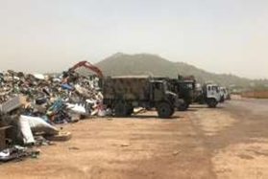

* GPS Module
* Arduino UNO
* GSM Module

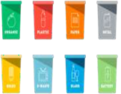 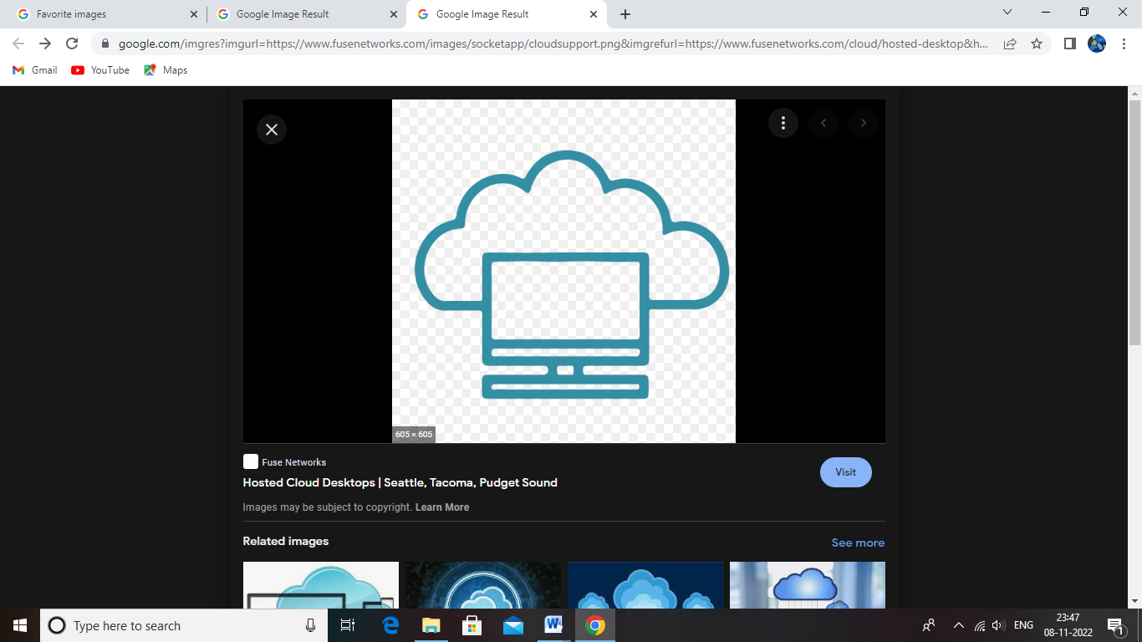



GARBAGE

COLLECTION

TRUCKS

Garbage Central Cloud

Server

 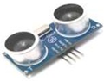

Ultrasonic

Municipal sensor

Corporation



GARBAGE

COLLECTION

TRUCKS